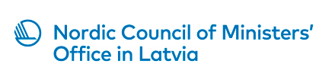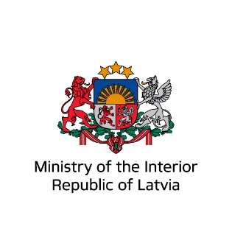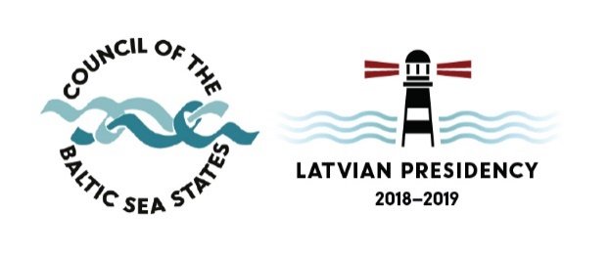
AGENDA
A Forum on Corporate Responsibility of Businesses: Prevention of Labour Exploitation
6 – 7 June 2019, Riga, Latvia
Venue: Ministry of the Interior, conference room 353, Čiekurkalna 1.līnija 1, Riga
Working language: English language
Day 1 – 6 June 2019

PANEL 1 Prevention & prosecution

09.30 – 10.00 | Arrival of participants, registration
10.00 – 10.20 | Opening speeches  Stefan Eriksson, Director, Nordic Council of Ministers Office in Latvia  LV – (TBC)  Valiant Richey, Acting Co-ordinator for Combating Trafficking in Human Beings, OSCE
10.20 – 10.50 | Matilde Skov Danstrøm, The Danish Centre against Human Trafficking (CMM), Head of Section  “Managing the Risk of Hidden Forced Labour – a guide for businesses and employers’ – aiming at preventing forced labour in Denmark”
10.50 – 11.20 | Anniina Jokinen, Senior Programme Officer, The European Institute for Crime Prevention and Control, affiliated with the United Nations (HEUNI)  “Guidelines for businesses for risk management: experiences in developing the work against labour exploitation in Finland”
11.20 – 11.50 | Coffee break
11.50 – 12.20 | Símon Sigvaldason, Judge, District Court of Reykjavik, Iceland  “Fighting Trafficking in Human Beings. What is happening in Iceland?”
12.20 – 12.50 | Sanni Martikainen, Corporate Responsibility Manager, SOK Corporation, Finland  “Radical transparency and human rights due diligence in S Group – case study on human rights impact assessment in Italian tomato supply chains”
12.50 – 13.10 | Time for questions and answers (all panellists)
13.10 – 14.00 | Lunch
14.00 – 14.45  14.45 – 15.00  Q&A | Key note speaker Anders Lisborg, Director and co-founder of Migration Management Advice (MMA)  “Business & Human Rights Initiatives to Prevent Exploitation in Global Supply Chains  - New Trends, Lessons Learnt & Ways Forward”  The presentation will provide an overview of challenges & opportunities for strategic multi-stakeholder partnerships in Business and Human Rights to combat labour exploitation in global supply chains. Based on direct experiences working with both Governments, Global Brands (Buyers) and Local Businesses (Producers) Anders Lisborg will share international perspectives on responsible business conduct and technology innovations within risk management, due diligence and ethical sourcing.
PANEL 2 OSCE PANEL
A panel on how public procurement practices could be leveraged to combat trafficking in human beings in supply chains. Governments should ensure that goods purchased and services contracted by state institutions are not being made through exploitation of people. The panel will discuss why it is important to use public procurement to prevent human trafficking, existing policies and practices adopted by countries in the OSCE area in this space, efforts by international actors to harmonize policies across different jurisdictions and how governments should cooperate with the private sector to combat human trafficking in supply chains.

Moderator - Valiant Richey, Acting Co-ordinator for Combating Trafficking in Human Beings, OSCE

15.00 – 15.25 | Pia Uhre Trulsen, Contract- and CSR manager, Division South-East, sykehusinnkjop, Norway
15.25 – 15.50 | Mark Heath, Deputy Director of Business Change, Gangmasters and Labour Abuse Authority, UK
15.50 – 16.10 | Coffee break
16.10 – 16.35 | Alexander Trautrims, Project Leader of the Unchained Supply Project, University of Nottingham Rights Lab
16.35 – 17.00 | Radu Cucos, Associate Officer on Combating Trafficking in Human Beings, OSCE
17.00 | First day of the Forum adjourn
19.00 – 21.00 | Reception hosted by the Nordic Council of Ministers’ Office in Latvia  Marijas street 13/3, Riga
Day 2 – 7 June 2019

PANEL 3 Practice & initiatives

10.00 – 10.30 | Sirle Blumberg, Head of Human Trafficking Counseling Service, Department of Victim Support and Prevention Services, Social Insurance Board  “Sometimes the hope is gone and justice seems so far... and then you make this call...”  Human Trafficking Prevention and Victim Helpline +372 6607 320
10.30 – 10.45 | Gediminas Noreika, Head of Illegal Activities Monitoring Division, State Labour Inspectorate of the Republic of Lithuania  “Problems and challenges which Lithuanian State Labour Inspectorate face on THB”
10.45 – 11.15 | Coffee break
11.15 – 11.45 | Anniina Jokinen, Senior Programme Officer, The European Institute for Crime Prevention and Control, affiliated with the United Nations (HEUNI)  “FLOW project: Uncovering the complexities between labour trafficking and economic crimes”
11.45 – 12.15 | Vineta Polatside, Head of Unit, Task Force against Trafficking in Human Beings, Council of the Baltic Sea States Secretariat  “Addressing Trafficking in Human Beings for Labour Exploitation in the Baltic Sea Region (ADSTRINGO). Topicality of identified challenges, achieved results and lessons learned today”
12.15 – 12.35 | Time for questions and answers (all panellists)
12.35 – 12.45 | Closing of the Forum
12.45 – 13.45 | Lunch and adjourn

Ms Daina Mežecka, Advisor of the Nordic Council of Ministers’ Office in Latvia, (+371) 29394399, daina@norden.lv
Ms Lāsma Stabiņa, National Anti-Trafficking Coordinator of the Republic of Latvia, CBSS TF-THB Chair, (+371) 67829674, (+371) 29382033; lasma.stabina@iem.gov.lv

